- Design a dashboard wireframe in Excel for a Zomato-style food delivery analytics report, including sections for Header, KPIs, Trends, and Insights using shapes and cell formatting.
ANSWERS:
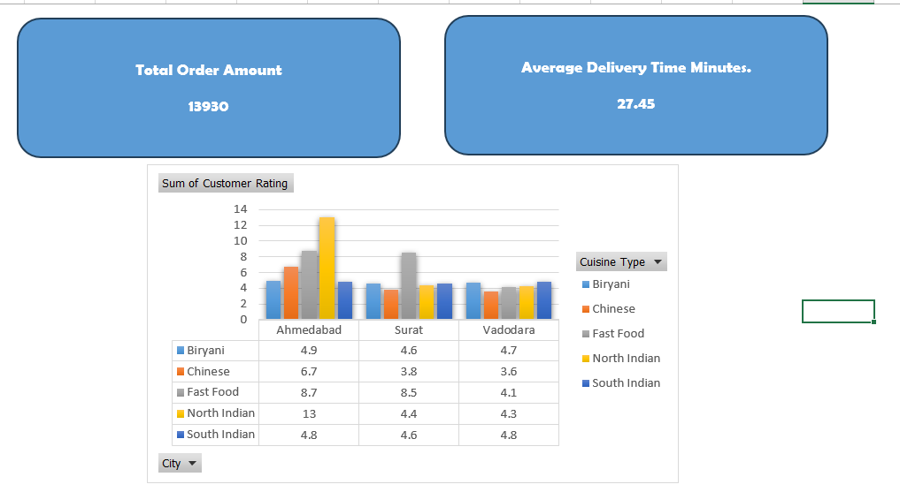

- Create three KPI cards in Excel that show the Min, Max, and Average order value from a sample dataset of food orders (order amounts in one column), using formulas and cell formatting for visual emphasis.
ANSWERS:
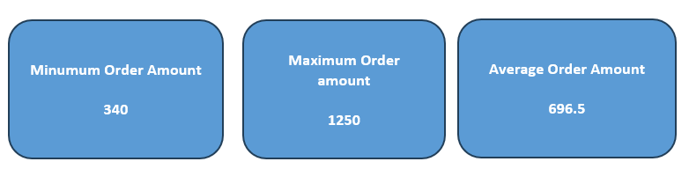

- Build a Donut chart in Excel to visualize the proportion of different cuisine types (e.g., Indian, Chinese, Italian) from a given order dataset, and format the chart to match a modern app dashboard style.
ANSWERS:

- Add a Waterfall chart in Excel to display the month-on-month change in total orders for a Swiggy-like delivery business, highlighting increases and decreases with different colors.

Hint: Use a sample table with monthly totals and apply the Waterfall chart type from the Insert menu.
ANSWERS:

- Apply alignment, spacing, and color theory principles to your dashboard: adjust all KPI cards and charts so they are evenly spaced, aligned, and use a consistent color palette inspired by your favorite app (e.g., Instagram, Spotify).
ANSWERS:
